**Blackjack Design Document**

**CS 401 Group 2**

**Spring 2025**

Revision History

|  |  |  |  |
| --- | --- | --- | --- |
| **Date** | **Revision** | **Description** | **Author** |
| 3/24/2025 | 1.0 | Start of Design Document | Mahlet Bekele, Brandom Wall, Cristian Gonzales, Kenny Yu |
| 4/6/2025 | 1.1 | Added new graphics in interface design | Armand Tirado |
| 4/6/2025 | 1.2 | Created Mock-up images for UI Design, System Architecture, Dealer’s point of view in game, and Player’s point of view in game | Brandon Wall |
| 4/6/2025 | 1.3 | Worked on use case diagram | Mahlet Bekele |
| 4/7/2025 | 1.4 | Continued working on mock-up images | Brandon Wall |
| 4/7/2025 | 1.5 | Worked on UML class diagrams | Brandon Wall |
| 4/7/2025 | 1.6 | Worked on UML class diagrams | Mahlet Bekele |
| 4/8/2025 | 1.7 | Worked on UML class diagrams | Brandon Wall |
|  |  |  |  |
|  |  |  |  |
|  |  |  |  |
|  |  |  |  |
|  |  |  |  |
|  |  |  |  |
|  |  |  |  |
|  |  |  |  |
|  |  |  |  |
|  |  |  |  |
|  |  |  |  |
|  |  |  |  |
|  |  |  |  |

Table of Contents

**1.** **Purpose** [**4**](https://usc-word-edit.officeapps.live.com/we/wordeditorframe.aspx?ui=en-US&rs=en-US&wopisrc=https%3A%2F%2Fmy.microsoftpersonalcontent.com%2Fpersonal%2F3aac43fbdf15eb06%2F_vti_bin%2Fwopi.ashx%2Ffiles%2F045397c60e42431ba4a664b5554dbb86&wdenableroaming=1&mscc=1&wdodb=1&hid=TLO%2F0%2F%2BLbUqqUKw4Bj3HqQ.0.0&sc=%7B%22pmo%22%3A%22https%3A%2F%2Fonedrive.live.com%22%2C%22redeem%22%3A%22aHR0cHM6Ly8xZHJ2Lm1zL3cvYy8zYWFjNDNmYmRmMTVlYjA2L0VjYVhVd1JDRGh0RHBLWmt0VlZOdTRZQkdSaHQ0LUFwMmh2MkdXSDgzNXM2RGc%22%7D&wdo=2&uih=onedrivecom&jsapi=1&jsapiver=v2&corrid=4775b3e0-e7c6-4fce-97ca-209444722b97&usid=4775b3e0-e7c6-4fce-97ca-209444722b97&newsession=1&sftc=1&uihit=editaspx&muv=1&cac=1&sams=1&mtf=1&sfp=1&sdp=1&hch=1&hwfh=1&dchat=1&ctp=LeastProtected&rct=Normal&wdorigin=Other&csc=1&instantedit=1&wopicomplete=1&wdredirectionreason=Unified_SingleFlush#__RefHeading___Toc19440719)

1.1. Scope [4](https://usc-word-edit.officeapps.live.com/we/wordeditorframe.aspx?ui=en-US&rs=en-US&wopisrc=https%3A%2F%2Fmy.microsoftpersonalcontent.com%2Fpersonal%2F3aac43fbdf15eb06%2F_vti_bin%2Fwopi.ashx%2Ffiles%2F045397c60e42431ba4a664b5554dbb86&wdenableroaming=1&mscc=1&wdodb=1&hid=TLO%2F0%2F%2BLbUqqUKw4Bj3HqQ.0.0&sc=%7B%22pmo%22%3A%22https%3A%2F%2Fonedrive.live.com%22%2C%22redeem%22%3A%22aHR0cHM6Ly8xZHJ2Lm1zL3cvYy8zYWFjNDNmYmRmMTVlYjA2L0VjYVhVd1JDRGh0RHBLWmt0VlZOdTRZQkdSaHQ0LUFwMmh2MkdXSDgzNXM2RGc%22%7D&wdo=2&uih=onedrivecom&jsapi=1&jsapiver=v2&corrid=4775b3e0-e7c6-4fce-97ca-209444722b97&usid=4775b3e0-e7c6-4fce-97ca-209444722b97&newsession=1&sftc=1&uihit=editaspx&muv=1&cac=1&sams=1&mtf=1&sfp=1&sdp=1&hch=1&hwfh=1&dchat=1&ctp=LeastProtected&rct=Normal&wdorigin=Other&csc=1&instantedit=1&wopicomplete=1&wdredirectionreason=Unified_SingleFlush#__RefHeading___Toc19440720)

1.2. Definitions, Acronyms, Abbreviations [4](https://usc-word-edit.officeapps.live.com/we/wordeditorframe.aspx?ui=en-US&rs=en-US&wopisrc=https%3A%2F%2Fmy.microsoftpersonalcontent.com%2Fpersonal%2F3aac43fbdf15eb06%2F_vti_bin%2Fwopi.ashx%2Ffiles%2F045397c60e42431ba4a664b5554dbb86&wdenableroaming=1&mscc=1&wdodb=1&hid=TLO%2F0%2F%2BLbUqqUKw4Bj3HqQ.0.0&sc=%7B%22pmo%22%3A%22https%3A%2F%2Fonedrive.live.com%22%2C%22redeem%22%3A%22aHR0cHM6Ly8xZHJ2Lm1zL3cvYy8zYWFjNDNmYmRmMTVlYjA2L0VjYVhVd1JDRGh0RHBLWmt0VlZOdTRZQkdSaHQ0LUFwMmh2MkdXSDgzNXM2RGc%22%7D&wdo=2&uih=onedrivecom&jsapi=1&jsapiver=v2&corrid=4775b3e0-e7c6-4fce-97ca-209444722b97&usid=4775b3e0-e7c6-4fce-97ca-209444722b97&newsession=1&sftc=1&uihit=editaspx&muv=1&cac=1&sams=1&mtf=1&sfp=1&sdp=1&hch=1&hwfh=1&dchat=1&ctp=LeastProtected&rct=Normal&wdorigin=Other&csc=1&instantedit=1&wopicomplete=1&wdredirectionreason=Unified_SingleFlush#__RefHeading___Toc19440721)

1.3. References [4](https://usc-word-edit.officeapps.live.com/we/wordeditorframe.aspx?ui=en-US&rs=en-US&wopisrc=https%3A%2F%2Fmy.microsoftpersonalcontent.com%2Fpersonal%2F3aac43fbdf15eb06%2F_vti_bin%2Fwopi.ashx%2Ffiles%2F045397c60e42431ba4a664b5554dbb86&wdenableroaming=1&mscc=1&wdodb=1&hid=TLO%2F0%2F%2BLbUqqUKw4Bj3HqQ.0.0&sc=%7B%22pmo%22%3A%22https%3A%2F%2Fonedrive.live.com%22%2C%22redeem%22%3A%22aHR0cHM6Ly8xZHJ2Lm1zL3cvYy8zYWFjNDNmYmRmMTVlYjA2L0VjYVhVd1JDRGh0RHBLWmt0VlZOdTRZQkdSaHQ0LUFwMmh2MkdXSDgzNXM2RGc%22%7D&wdo=2&uih=onedrivecom&jsapi=1&jsapiver=v2&corrid=4775b3e0-e7c6-4fce-97ca-209444722b97&usid=4775b3e0-e7c6-4fce-97ca-209444722b97&newsession=1&sftc=1&uihit=editaspx&muv=1&cac=1&sams=1&mtf=1&sfp=1&sdp=1&hch=1&hwfh=1&dchat=1&ctp=LeastProtected&rct=Normal&wdorigin=Other&csc=1&instantedit=1&wopicomplete=1&wdredirectionreason=Unified_SingleFlush#__RefHeading___Toc19440722)

1.4. Overview [4](https://usc-word-edit.officeapps.live.com/we/wordeditorframe.aspx?ui=en-US&rs=en-US&wopisrc=https%3A%2F%2Fmy.microsoftpersonalcontent.com%2Fpersonal%2F3aac43fbdf15eb06%2F_vti_bin%2Fwopi.ashx%2Ffiles%2F045397c60e42431ba4a664b5554dbb86&wdenableroaming=1&mscc=1&wdodb=1&hid=TLO%2F0%2F%2BLbUqqUKw4Bj3HqQ.0.0&sc=%7B%22pmo%22%3A%22https%3A%2F%2Fonedrive.live.com%22%2C%22redeem%22%3A%22aHR0cHM6Ly8xZHJ2Lm1zL3cvYy8zYWFjNDNmYmRmMTVlYjA2L0VjYVhVd1JDRGh0RHBLWmt0VlZOdTRZQkdSaHQ0LUFwMmh2MkdXSDgzNXM2RGc%22%7D&wdo=2&uih=onedrivecom&jsapi=1&jsapiver=v2&corrid=4775b3e0-e7c6-4fce-97ca-209444722b97&usid=4775b3e0-e7c6-4fce-97ca-209444722b97&newsession=1&sftc=1&uihit=editaspx&muv=1&cac=1&sams=1&mtf=1&sfp=1&sdp=1&hch=1&hwfh=1&dchat=1&ctp=LeastProtected&rct=Normal&wdorigin=Other&csc=1&instantedit=1&wopicomplete=1&wdredirectionreason=Unified_SingleFlush#__RefHeading___Toc19440723)

**2.**  **SYSTEM ARCHITECTURE** ...............................................................................................................[**5**](https://usc-word-edit.officeapps.live.com/we/wordeditorframe.aspx?ui=en-US&rs=en-US&wopisrc=https%3A%2F%2Fmy.microsoftpersonalcontent.com%2Fpersonal%2F3aac43fbdf15eb06%2F_vti_bin%2Fwopi.ashx%2Ffiles%2F045397c60e42431ba4a664b5554dbb86&wdenableroaming=1&mscc=1&wdodb=1&hid=TLO%2F0%2F%2BLbUqqUKw4Bj3HqQ.0.0&sc=%7B%22pmo%22%3A%22https%3A%2F%2Fonedrive.live.com%22%2C%22redeem%22%3A%22aHR0cHM6Ly8xZHJ2Lm1zL3cvYy8zYWFjNDNmYmRmMTVlYjA2L0VjYVhVd1JDRGh0RHBLWmt0VlZOdTRZQkdSaHQ0LUFwMmh2MkdXSDgzNXM2RGc%22%7D&wdo=2&uih=onedrivecom&jsapi=1&jsapiver=v2&corrid=4775b3e0-e7c6-4fce-97ca-209444722b97&usid=4775b3e0-e7c6-4fce-97ca-209444722b97&newsession=1&sftc=1&uihit=editaspx&muv=1&cac=1&sams=1&mtf=1&sfp=1&sdp=1&hch=1&hwfh=1&dchat=1&ctp=LeastProtected&rct=Normal&wdorigin=Other&csc=1&instantedit=1&wopicomplete=1&wdredirectionreason=Unified_SingleFlush#__RefHeading___Toc19440724)

2.1. Product Perspective...................................................................................................................... [5](https://usc-word-edit.officeapps.live.com/we/wordeditorframe.aspx?ui=en-US&rs=en-US&wopisrc=https%3A%2F%2Fmy.microsoftpersonalcontent.com%2Fpersonal%2F3aac43fbdf15eb06%2F_vti_bin%2Fwopi.ashx%2Ffiles%2F045397c60e42431ba4a664b5554dbb86&wdenableroaming=1&mscc=1&wdodb=1&hid=TLO%2F0%2F%2BLbUqqUKw4Bj3HqQ.0.0&sc=%7B%22pmo%22%3A%22https%3A%2F%2Fonedrive.live.com%22%2C%22redeem%22%3A%22aHR0cHM6Ly8xZHJ2Lm1zL3cvYy8zYWFjNDNmYmRmMTVlYjA2L0VjYVhVd1JDRGh0RHBLWmt0VlZOdTRZQkdSaHQ0LUFwMmh2MkdXSDgzNXM2RGc%22%7D&wdo=2&uih=onedrivecom&jsapi=1&jsapiver=v2&corrid=4775b3e0-e7c6-4fce-97ca-209444722b97&usid=4775b3e0-e7c6-4fce-97ca-209444722b97&newsession=1&sftc=1&uihit=editaspx&muv=1&cac=1&sams=1&mtf=1&sfp=1&sdp=1&hch=1&hwfh=1&dchat=1&ctp=LeastProtected&rct=Normal&wdorigin=Other&csc=1&instantedit=1&wopicomplete=1&wdredirectionreason=Unified_SingleFlush#__RefHeading___Toc19440725)

2.2. Product Architecture................................................................................................................. [5](https://usc-word-edit.officeapps.live.com/we/wordeditorframe.aspx?ui=en-US&rs=en-US&wopisrc=https%3A%2F%2Fmy.microsoftpersonalcontent.com%2Fpersonal%2F3aac43fbdf15eb06%2F_vti_bin%2Fwopi.ashx%2Ffiles%2F045397c60e42431ba4a664b5554dbb86&wdenableroaming=1&mscc=1&wdodb=1&hid=TLO%2F0%2F%2BLbUqqUKw4Bj3HqQ.0.0&sc=%7B%22pmo%22%3A%22https%3A%2F%2Fonedrive.live.com%22%2C%22redeem%22%3A%22aHR0cHM6Ly8xZHJ2Lm1zL3cvYy8zYWFjNDNmYmRmMTVlYjA2L0VjYVhVd1JDRGh0RHBLWmt0VlZOdTRZQkdSaHQ0LUFwMmh2MkdXSDgzNXM2RGc%22%7D&wdo=2&uih=onedrivecom&jsapi=1&jsapiver=v2&corrid=4775b3e0-e7c6-4fce-97ca-209444722b97&usid=4775b3e0-e7c6-4fce-97ca-209444722b97&newsession=1&sftc=1&uihit=editaspx&muv=1&cac=1&sams=1&mtf=1&sfp=1&sdp=1&hch=1&hwfh=1&dchat=1&ctp=LeastProtected&rct=Normal&wdorigin=Other&csc=1&instantedit=1&wopicomplete=1&wdredirectionreason=Unified_SingleFlush#__RefHeading___Toc19440726)

2.3. Product Functionality/Features [5](https://usc-word-edit.officeapps.live.com/we/wordeditorframe.aspx?ui=en-US&rs=en-US&wopisrc=https%3A%2F%2Fmy.microsoftpersonalcontent.com%2Fpersonal%2F3aac43fbdf15eb06%2F_vti_bin%2Fwopi.ashx%2Ffiles%2F045397c60e42431ba4a664b5554dbb86&wdenableroaming=1&mscc=1&wdodb=1&hid=TLO%2F0%2F%2BLbUqqUKw4Bj3HqQ.0.0&sc=%7B%22pmo%22%3A%22https%3A%2F%2Fonedrive.live.com%22%2C%22redeem%22%3A%22aHR0cHM6Ly8xZHJ2Lm1zL3cvYy8zYWFjNDNmYmRmMTVlYjA2L0VjYVhVd1JDRGh0RHBLWmt0VlZOdTRZQkdSaHQ0LUFwMmh2MkdXSDgzNXM2RGc%22%7D&wdo=2&uih=onedrivecom&jsapi=1&jsapiver=v2&corrid=4775b3e0-e7c6-4fce-97ca-209444722b97&usid=4775b3e0-e7c6-4fce-97ca-209444722b97&newsession=1&sftc=1&uihit=editaspx&muv=1&cac=1&sams=1&mtf=1&sfp=1&sdp=1&hch=1&hwfh=1&dchat=1&ctp=LeastProtected&rct=Normal&wdorigin=Other&csc=1&instantedit=1&wopicomplete=1&wdredirectionreason=Unified_SingleFlush#__RefHeading___Toc19440727)

2.4. Constraints [5](https://usc-word-edit.officeapps.live.com/we/wordeditorframe.aspx?ui=en-US&rs=en-US&wopisrc=https%3A%2F%2Fmy.microsoftpersonalcontent.com%2Fpersonal%2F3aac43fbdf15eb06%2F_vti_bin%2Fwopi.ashx%2Ffiles%2F045397c60e42431ba4a664b5554dbb86&wdenableroaming=1&mscc=1&wdodb=1&hid=TLO%2F0%2F%2BLbUqqUKw4Bj3HqQ.0.0&sc=%7B%22pmo%22%3A%22https%3A%2F%2Fonedrive.live.com%22%2C%22redeem%22%3A%22aHR0cHM6Ly8xZHJ2Lm1zL3cvYy8zYWFjNDNmYmRmMTVlYjA2L0VjYVhVd1JDRGh0RHBLWmt0VlZOdTRZQkdSaHQ0LUFwMmh2MkdXSDgzNXM2RGc%22%7D&wdo=2&uih=onedrivecom&jsapi=1&jsapiver=v2&corrid=4775b3e0-e7c6-4fce-97ca-209444722b97&usid=4775b3e0-e7c6-4fce-97ca-209444722b97&newsession=1&sftc=1&uihit=editaspx&muv=1&cac=1&sams=1&mtf=1&sfp=1&sdp=1&hch=1&hwfh=1&dchat=1&ctp=LeastProtected&rct=Normal&wdorigin=Other&csc=1&instantedit=1&wopicomplete=1&wdredirectionreason=Unified_SingleFlush#__RefHeading___Toc19440728)

2.5. Assumptions and Dependencies [5](https://usc-word-edit.officeapps.live.com/we/wordeditorframe.aspx?ui=en-US&rs=en-US&wopisrc=https%3A%2F%2Fmy.microsoftpersonalcontent.com%2Fpersonal%2F3aac43fbdf15eb06%2F_vti_bin%2Fwopi.ashx%2Ffiles%2F045397c60e42431ba4a664b5554dbb86&wdenableroaming=1&mscc=1&wdodb=1&hid=TLO%2F0%2F%2BLbUqqUKw4Bj3HqQ.0.0&sc=%7B%22pmo%22%3A%22https%3A%2F%2Fonedrive.live.com%22%2C%22redeem%22%3A%22aHR0cHM6Ly8xZHJ2Lm1zL3cvYy8zYWFjNDNmYmRmMTVlYjA2L0VjYVhVd1JDRGh0RHBLWmt0VlZOdTRZQkdSaHQ0LUFwMmh2MkdXSDgzNXM2RGc%22%7D&wdo=2&uih=onedrivecom&jsapi=1&jsapiver=v2&corrid=4775b3e0-e7c6-4fce-97ca-209444722b97&usid=4775b3e0-e7c6-4fce-97ca-209444722b97&newsession=1&sftc=1&uihit=editaspx&muv=1&cac=1&sams=1&mtf=1&sfp=1&sdp=1&hch=1&hwfh=1&dchat=1&ctp=LeastProtected&rct=Normal&wdorigin=Other&csc=1&instantedit=1&wopicomplete=1&wdredirectionreason=Unified_SingleFlush#__RefHeading___Toc19440729)

**3.** **CLASS DIAGRAMS**........................................................................................................................

**4. USE CASE SPECIFICATIONS** [**6**](https://usc-word-edit.officeapps.live.com/we/wordeditorframe.aspx?ui=en-US&rs=en-US&wopisrc=https%3A%2F%2Fmy.microsoftpersonalcontent.com%2Fpersonal%2F3aac43fbdf15eb06%2F_vti_bin%2Fwopi.ashx%2Ffiles%2F045397c60e42431ba4a664b5554dbb86&wdenableroaming=1&mscc=1&wdodb=1&hid=TLO%2F0%2F%2BLbUqqUKw4Bj3HqQ.0.0&sc=%7B%22pmo%22%3A%22https%3A%2F%2Fonedrive.live.com%22%2C%22redeem%22%3A%22aHR0cHM6Ly8xZHJ2Lm1zL3cvYy8zYWFjNDNmYmRmMTVlYjA2L0VjYVhVd1JDRGh0RHBLWmt0VlZOdTRZQkdSaHQ0LUFwMmh2MkdXSDgzNXM2RGc%22%7D&wdo=2&uih=onedrivecom&jsapi=1&jsapiver=v2&corrid=4775b3e0-e7c6-4fce-97ca-209444722b97&usid=4775b3e0-e7c6-4fce-97ca-209444722b97&newsession=1&sftc=1&uihit=editaspx&muv=1&cac=1&sams=1&mtf=1&sfp=1&sdp=1&hch=1&hwfh=1&dchat=1&ctp=LeastProtected&rct=Normal&wdorigin=Other&csc=1&instantedit=1&wopicomplete=1&wdredirectionreason=Unified_SingleFlush#__RefHeading___Toc19440730)

3.1. Functional Requirements [6](https://usc-word-edit.officeapps.live.com/we/wordeditorframe.aspx?ui=en-US&rs=en-US&wopisrc=https%3A%2F%2Fmy.microsoftpersonalcontent.com%2Fpersonal%2F3aac43fbdf15eb06%2F_vti_bin%2Fwopi.ashx%2Ffiles%2F045397c60e42431ba4a664b5554dbb86&wdenableroaming=1&mscc=1&wdodb=1&hid=TLO%2F0%2F%2BLbUqqUKw4Bj3HqQ.0.0&sc=%7B%22pmo%22%3A%22https%3A%2F%2Fonedrive.live.com%22%2C%22redeem%22%3A%22aHR0cHM6Ly8xZHJ2Lm1zL3cvYy8zYWFjNDNmYmRmMTVlYjA2L0VjYVhVd1JDRGh0RHBLWmt0VlZOdTRZQkdSaHQ0LUFwMmh2MkdXSDgzNXM2RGc%22%7D&wdo=2&uih=onedrivecom&jsapi=1&jsapiver=v2&corrid=4775b3e0-e7c6-4fce-97ca-209444722b97&usid=4775b3e0-e7c6-4fce-97ca-209444722b97&newsession=1&sftc=1&uihit=editaspx&muv=1&cac=1&sams=1&mtf=1&sfp=1&sdp=1&hch=1&hwfh=1&dchat=1&ctp=LeastProtected&rct=Normal&wdorigin=Other&csc=1&instantedit=1&wopicomplete=1&wdredirectionreason=Unified_SingleFlush#__RefHeading___Toc19440731)

3.2. External Interface Requirements [6](https://usc-word-edit.officeapps.live.com/we/wordeditorframe.aspx?ui=en-US&rs=en-US&wopisrc=https%3A%2F%2Fmy.microsoftpersonalcontent.com%2Fpersonal%2F3aac43fbdf15eb06%2F_vti_bin%2Fwopi.ashx%2Ffiles%2F045397c60e42431ba4a664b5554dbb86&wdenableroaming=1&mscc=1&wdodb=1&hid=TLO%2F0%2F%2BLbUqqUKw4Bj3HqQ.0.0&sc=%7B%22pmo%22%3A%22https%3A%2F%2Fonedrive.live.com%22%2C%22redeem%22%3A%22aHR0cHM6Ly8xZHJ2Lm1zL3cvYy8zYWFjNDNmYmRmMTVlYjA2L0VjYVhVd1JDRGh0RHBLWmt0VlZOdTRZQkdSaHQ0LUFwMmh2MkdXSDgzNXM2RGc%22%7D&wdo=2&uih=onedrivecom&jsapi=1&jsapiver=v2&corrid=4775b3e0-e7c6-4fce-97ca-209444722b97&usid=4775b3e0-e7c6-4fce-97ca-209444722b97&newsession=1&sftc=1&uihit=editaspx&muv=1&cac=1&sams=1&mtf=1&sfp=1&sdp=1&hch=1&hwfh=1&dchat=1&ctp=LeastProtected&rct=Normal&wdorigin=Other&csc=1&instantedit=1&wopicomplete=1&wdredirectionreason=Unified_SingleFlush#__RefHeading___Toc19440736)

3.3. Internal Interface Requirements [7](https://usc-word-edit.officeapps.live.com/we/wordeditorframe.aspx?ui=en-US&rs=en-US&wopisrc=https%3A%2F%2Fmy.microsoftpersonalcontent.com%2Fpersonal%2F3aac43fbdf15eb06%2F_vti_bin%2Fwopi.ashx%2Ffiles%2F045397c60e42431ba4a664b5554dbb86&wdenableroaming=1&mscc=1&wdodb=1&hid=TLO%2F0%2F%2BLbUqqUKw4Bj3HqQ.0.0&sc=%7B%22pmo%22%3A%22https%3A%2F%2Fonedrive.live.com%22%2C%22redeem%22%3A%22aHR0cHM6Ly8xZHJ2Lm1zL3cvYy8zYWFjNDNmYmRmMTVlYjA2L0VjYVhVd1JDRGh0RHBLWmt0VlZOdTRZQkdSaHQ0LUFwMmh2MkdXSDgzNXM2RGc%22%7D&wdo=2&uih=onedrivecom&jsapi=1&jsapiver=v2&corrid=4775b3e0-e7c6-4fce-97ca-209444722b97&usid=4775b3e0-e7c6-4fce-97ca-209444722b97&newsession=1&sftc=1&uihit=editaspx&muv=1&cac=1&sams=1&mtf=1&sfp=1&sdp=1&hch=1&hwfh=1&dchat=1&ctp=LeastProtected&rct=Normal&wdorigin=Other&csc=1&instantedit=1&wopicomplete=1&wdredirectionreason=Unified_SingleFlush#__RefHeading___Toc19440737)

**5.** **Sequence diagrams** [**8**](https://usc-word-edit.officeapps.live.com/we/wordeditorframe.aspx?ui=en-US&rs=en-US&wopisrc=https%3A%2F%2Fmy.microsoftpersonalcontent.com%2Fpersonal%2F3aac43fbdf15eb06%2F_vti_bin%2Fwopi.ashx%2Ffiles%2F045397c60e42431ba4a664b5554dbb86&wdenableroaming=1&mscc=1&wdodb=1&hid=TLO%2F0%2F%2BLbUqqUKw4Bj3HqQ.0.0&sc=%7B%22pmo%22%3A%22https%3A%2F%2Fonedrive.live.com%22%2C%22redeem%22%3A%22aHR0cHM6Ly8xZHJ2Lm1zL3cvYy8zYWFjNDNmYmRmMTVlYjA2L0VjYVhVd1JDRGh0RHBLWmt0VlZOdTRZQkdSaHQ0LUFwMmh2MkdXSDgzNXM2RGc%22%7D&wdo=2&uih=onedrivecom&jsapi=1&jsapiver=v2&corrid=4775b3e0-e7c6-4fce-97ca-209444722b97&usid=4775b3e0-e7c6-4fce-97ca-209444722b97&newsession=1&sftc=1&uihit=editaspx&muv=1&cac=1&sams=1&mtf=1&sfp=1&sdp=1&hch=1&hwfh=1&dchat=1&ctp=LeastProtected&rct=Normal&wdorigin=Other&csc=1&instantedit=1&wopicomplete=1&wdredirectionreason=Unified_SingleFlush#__RefHeading___Toc19440738)

4.1. Security and Privacy Requirements [8](https://usc-word-edit.officeapps.live.com/we/wordeditorframe.aspx?ui=en-US&rs=en-US&wopisrc=https%3A%2F%2Fmy.microsoftpersonalcontent.com%2Fpersonal%2F3aac43fbdf15eb06%2F_vti_bin%2Fwopi.ashx%2Ffiles%2F045397c60e42431ba4a664b5554dbb86&wdenableroaming=1&mscc=1&wdodb=1&hid=TLO%2F0%2F%2BLbUqqUKw4Bj3HqQ.0.0&sc=%7B%22pmo%22%3A%22https%3A%2F%2Fonedrive.live.com%22%2C%22redeem%22%3A%22aHR0cHM6Ly8xZHJ2Lm1zL3cvYy8zYWFjNDNmYmRmMTVlYjA2L0VjYVhVd1JDRGh0RHBLWmt0VlZOdTRZQkdSaHQ0LUFwMmh2MkdXSDgzNXM2RGc%22%7D&wdo=2&uih=onedrivecom&jsapi=1&jsapiver=v2&corrid=4775b3e0-e7c6-4fce-97ca-209444722b97&usid=4775b3e0-e7c6-4fce-97ca-209444722b97&newsession=1&sftc=1&uihit=editaspx&muv=1&cac=1&sams=1&mtf=1&sfp=1&sdp=1&hch=1&hwfh=1&dchat=1&ctp=LeastProtected&rct=Normal&wdorigin=Other&csc=1&instantedit=1&wopicomplete=1&wdredirectionreason=Unified_SingleFlush#__RefHeading___Toc19440739)

**6.** **Interface design**......................................................................................................................... [8](https://usc-word-edit.officeapps.live.com/we/wordeditorframe.aspx?ui=en-US&rs=en-US&wopisrc=https%3A%2F%2Fmy.microsoftpersonalcontent.com%2Fpersonal%2F3aac43fbdf15eb06%2F_vti_bin%2Fwopi.ashx%2Ffiles%2F045397c60e42431ba4a664b5554dbb86&wdenableroaming=1&mscc=1&wdodb=1&hid=TLO%2F0%2F%2BLbUqqUKw4Bj3HqQ.0.0&sc=%7B%22pmo%22%3A%22https%3A%2F%2Fonedrive.live.com%22%2C%22redeem%22%3A%22aHR0cHM6Ly8xZHJ2Lm1zL3cvYy8zYWFjNDNmYmRmMTVlYjA2L0VjYVhVd1JDRGh0RHBLWmt0VlZOdTRZQkdSaHQ0LUFwMmh2MkdXSDgzNXM2RGc%22%7D&wdo=2&uih=onedrivecom&jsapi=1&jsapiver=v2&corrid=4775b3e0-e7c6-4fce-97ca-209444722b97&usid=4775b3e0-e7c6-4fce-97ca-209444722b97&newsession=1&sftc=1&uihit=editaspx&muv=1&cac=1&sams=1&mtf=1&sfp=1&sdp=1&hch=1&hwfh=1&dchat=1&ctp=LeastProtected&rct=Normal&wdorigin=Other&csc=1&instantedit=1&wopicomplete=1&wdredirectionreason=Unified_SingleFlush#__RefHeading___Toc19440739)

1. **Purpose**
   1. **Scope**

This document will catalog the user, system, and hardware requirements for the Multiplayer Blackjack Gaming System. It will define what the system must accomplish but will not detail how these requirements will be implemented.

* 1. **Definitions, Acronyms, Abbreviations**
     1. Hand: The collection of cards each player possesses during the game.
     2. Table: A game room consisting of one dealer and 0-6 players.
     3. Dealer: The person who distributes cards to active players and plays against them.
     4. Blackjack: A hand consisting of two cards whose sum equals 21.
     5. Bet: The amount of money the player wishes to wager that they’ll win against the dealer
     6. Table Limit: The minimum and maximum amount players can bet at a table.
     7. Hit: An action made by a player that will adds the top card of the deck into the player’s hand.
     8. Stand: An action made by the player when the player wishes to end their turn.
     9. Fold: When a player decides to forfeit the game, losing all money they’ve bet for that game.
     10. Bust: When a player hand total is over 21 resulting in a loss.
     11. Card: An object that has a numerical value and a card symbol that is either a spade, diamond, heart, or club. Numerical values range from 1-11.
     12. Card Symbol: Each card has a card symbol, which is either a spade, diamond, heart, or club.
     13. Ace Card: A variant of a normal card that has a numerical value of either 1 or 11 by the player's choice and has a card symbol.
     14. Face Card: A variant of a normal card but has a numerical value of 10 and is called either a Jack Queen or King. Face cards also have one of the four card symbols.
     15. Deck: A collection of 52 unique cards, where there are four versions of each card in the deck, each with one of the four card symbols.
     16. Shoe: A collection of multiple decks.
     17. Split: An action made by the player when a player's initial hand consists of 2 identical cards and wants to create two separate hands, each consisting of one of the identical cards from the initial hand and the next top card from the shoe.
     18. Double down is a move in blackjack where a player doubles their bet and receives only one more card.
     19. Push: When the sum of the player’s hand is equal to the sum of the dealer’s hand.
     20. TCP/IP (Transmission Control Protocol/Internet Protocol): a group of network protocols that let the client and the server communicate.
     21. GUI (Graphical User Interface): the game’s visual interface that allows players to interact with it.
  2. **References**
  3. **Overview**

1. **System Architecture**
2. **Class Diagrams**
   1. **Player Class**
   2. **Dealer Class**
   3. **Table Class**
   4. **GUI Class**
3. **Use Case Specifications**

# 1. **Purpose**

This document outlines the requirements for the Multiplayer Blackjack game.

## 1.1 **Scope**

This document will catalog the user, system, and hardware requirements for the Multiplayer Blackjack Gaming System. It will define what the system must accomplish but will not detail how these requirements will be implemented.

## 1.2 **Definitions, Acronyms, Abbreviations**

* + 1. Hand: The collection of cards each player possesses during the game.
    2. Table: A game room consisting of one dealer and 0-6 players.
    3. Dealer: The person who distributes cards to active players and plays against them.
    4. Blackjack: A hand consisting of two cards whose sum equals 21.
    5. Bet: The amount of money the player wishes to wager that they’ll win against the dealer
    6. Table Limit: The minimum and maximum amount players can bet at a table.
    7. Hit: An action made by a player that will adds the top card of the deck into the player’s hand.
    8. Stand: An action made by the player when the player wishes to end their turn.
    9. Fold: When a player decides to forfeit the game, losing all money they’ve bet for that game.
    10. Bust: When a player hand total is over 21 resulting in a loss.
    11. Card: An object that has a numerical value and a card symbol that is either a spade, diamond, heart, or club. Numerical values range from 1-11.
    12. Card Symbol: Each card has a card symbol, which is either a spade, diamond, heart, or club.
    13. Ace Card: A variant of a normal card that has a numerical value of either 1 or 11 by the player's choice and has a card symbol.
    14. Face Card: A variant of a normal card but has a numerical value of 10 and is called either a Jack Queen or King. Face cards also have one of the four card symbols.
    15. Deck: A collection of 52 unique cards, where there are four versions of each card in the deck, each with one of the four card symbols.
    16. Shoe: A collection of multiple decks.
    17. Split: An action made by the player when a player's initial hand consists of 2 identical cards and wants to create two separate hands, each consisting of one of the identical cards from the initial hand and the next top card from the shoe.
    18. Double down is a move in blackjack where a player doubles their bet and receives only one more card.
    19. Push: When the sum of the player’s hand is equal to the sum of the dealer’s hand.
        1. TCP/IP (Transmission Control Protocol/Internet Protocol): a group of network protocols that let the client and the server communicate.
        2. GUI (Graphical User Interface): the game’s visual interface that allows players to interact with it.

## 1.3 **References**

Use Case Specification Document: Refer to Use Case Specification.docx

UML Use Case Diagrams Document: Refer to Use Case Diagram Blackjack.docx

Class Diagrams: Refer to UML Class Diagram Blackjack.docx

Sequence Diagrams: Refer to UML Sequence Diagrams Blackjack.docx

GitHub Repository: Refer to: <https://github.com/bwalldev/CS401_BlackJackGroupProject>

Gantt Chart: Refer to Gantt project planner.xlsx

## 1.4 **Overview**

The multiplayer blackjack gaming system is a Java-based application with a GUI, enabling real players to join virtual tables, place bets, and play under standard blackjack rules. It operates over TCP/IP, ensuring real-time gameplay, fund transactions, fair play, and minimal cheating.

# 2. **Use Case Specifications**

|  |  |
| --- | --- |
| **Use Case ID** | **UC-1** |
| **Use Case Name** | Player Login |
| **Relevant Requirements** | * · 3.1.1.1 |
| **Primary Actors** | * · Player |
| **Pre-conditions** | * · Player has an existing account |
| **Post-conditions** | * · Player is logged in successfully and is ready to start the game |
| **Basic Flow or Main Scenario** | * 1. The player enters the username and password. System verifies player, then if valid, player heads to the lobby. |
| **Extensions or Alternate Path** | * 1. If invalid prompts an error message to enter a valid credential or create an account. |
| **Exceptions** | * · If there is no internet, then you cannot login, even if valid credentials are input. |
| **Related Use Cases** | * · UC2 * · UC3 |

|  |  |
| --- | --- |
| **Use Case ID** | **UC-2** |
| **Use Case Name** | Dealer Login |
| **Relevant Requirements** | 3.1.1.1 |
| **Primary Actors** | * · Dealer |
| **Pre-conditions** | * · Dealer has an account |
| **Post-conditions** | * · Dealer is logged in successfully and has access to game management tool |
| **Basic Flow or Main Scenario** | * 1. The dealer enters the username and password. The system verifies dealer then if valid dealer accesses the game management system. |
| **Extensions or Alternate Path** | * 1. If the invalid system will prompt error message |
| **Exceptions** | * · If there is no internet, then you cannot login, even if valid credentials are input. |
| **Related Use Cases** | * · Player login * · Game management |

|  |  |
| --- | --- |
| **Use Case ID** | **UC-3** |
| **Use Case Name** | Player Fund Management |
| **Relevant Requirements** | 3.1.5.1  3.1.2.2 |
| **Primary Actors** | * · Player |
| **Pre-conditions** | * · Player is logged in |
| **Post-conditions** | * · Player fund changes after bets and wins |
| **Basic Flow or Main Scenario** | * 1. Players have funds in their account to play if they do not add funds to the account. Then the player places a bet at the start. Then the system deducts the amount from the player’s balance. After the game ends, if a player wins the game, then funds will be added to their account. They can request to withdraw the funds. |
| **Extensions or Alternate Path** | * 1. If there are no funds in account for the bet, prompt an error message (e.g., insufficient!). Add funds to player's account. |
| **Exceptions** | * · Transaction fail system will tell player system failed massage |
| **Related Use Cases** | * · UC-1 * · Betting management |

|  |  |
| --- | --- |
| **Use Case ID** | **UC-4** |
| **Use Case Name** | Game Management |
| **Relevant Requirements** | 3.1.4 |
| **Primary Actors** | * · Dealer |
| **Pre-conditions** | * · Dealer is logged in, and a new table is created and visible in the lobby. |
| **Post-conditions** | * · Game is setup, and players can join the lobby, and the game is ready to start when the minimum player count is met |
| **Basic Flow or Main Scenario** | * 1. The dealer can create a new table. Players can join the table if they have a valid fund, and the maximum number of players is not reached. Once the minimum required players have joined, the dealer starts the game. The game system controls the flow of the game. And the game continues until the round is over and winnings are distributed. |
| **Extensions or Alternate Path** | * 1. If there are no players, the table will stay open until new player joins |
| **Exceptions** | * · If deal disconnects, the game will end, and players will be refunded |
| **Related Use Casess** | * UC-2 |

|  |  |
| --- | --- |
| **Use Case ID** | **UC-5** |
| **Use Case Name** | Player Table Pick |
| **Relevant Requirements** | 3.1.5.4  3.1.7.1  3.2.7 |
| **Primary Actors** | * · Player |
| **Pre-conditions** | * · The player must be logged into the game lobby |
| **Post-conditions** | * · Player will now be in a table |
| **Basic Flow or Main Scenario** | * 1. Player navigates to game lobby * 2. Game shows all the tables in the lobby * 3. Player picks a table |
| **Extensions or Alternate Path** | * 1. Table is full * 2. The player has insufficient funds for the minimum bet * 3. Table is closed before player can join |
| **Exceptions** | * · Player Connection issue occurs when player is joining a table * · Dealer connection issue occurs when player is joining a table. |
| **Related Use Cases** | * · UC-1 * · UC-3 * · UC-4 |

|  |  |
| --- | --- |
| **Use Case ID** | **UC-6** |
| **Use Case Name** | Player Bet |
| **Relevant Requirements** | 3.1.2.1  3.1.2.4  3.1.2.5 |
| **Primary Actors** | * · Player |
| **Pre-conditions** | * · Player must be logged in and seated at a table * · Game round must not yet start |
| **Post-conditions** | * · Player balance is updated after placing bet * · System moves on from player bet to prompt other players to place their bets. |
| **Basic Flow or Main Scenario** | * 1. Player is prompted to place bet * 2. Player selects bet amount * 3. System checks if player has enough funds * 4. System deducts bet from player balance * 5. Player waits for dealer to start round |
| **Extensions or Alternate Path** | * Player has insufficient funds to bet with |
| **Related Use Cases** | * UC-3 |

|  |  |
| --- | --- |
| **Use Case ID** | **UC-7** |
| **Use Case Name** | Dealer Starts around |
| **Relevant Requirements** | 3.1.6 |
| **Primary Actors** | * · Dealer |
| **Pre-conditions** | * · All players on the table have placed their bets |
| **Post-conditions** | * · Each player and dealer receive their first cards |
| **Basic Flow or Main Scenario** | * 1. Dealer starts round * 2. Dealer gives 2 cards to each player one facing up the other facing down. * 3. The system checks if any player has a blackjack * 4. The first player takes their turn deciding to hit, stand, double down, split, or leave game |
| **Extensions or Alternate Path** | * 1. If a player has a blackjack, they win and the round ends * 2. If dealer has a blackjack they win and the round ends |
| **Exceptions** | * · Player disconnects in the middle of the round and they are resent to lobby. |
| **Related Use Cases** | * · UC-5 * · UC-6 |

|  |  |
| --- | --- |
| **Use Case ID** | **UC-8** |
| **Use Case Name** | Player Plays |
| **Relevant Requirements** | 3.2.3  3.2.6 |
| **Primary Actors** | * · Player |
| **Pre-conditions** | * · Its currently players turn * · Player has been given initial cards |
| **Post-conditions** | * · Player’s action is recorded by system |
| **Basic Flow or Main Scenario** | * 1. The system’s GUI prompts a menu of actions a player can take. * 2. Player chooses one of the following options * · Hit: Dealer gives player an extra card (If the value surpasses 21 then the player loses by busting * · Stand: player keeps the hand they have and end their turn * · Double down: Player doubles their bet and gets yet another card * · Split: If a player has 2 cards of the same value, then they can be split into 2 separate hands. * · Leave game: player can leave the game forfeiting their bet. * 3. System updates player and game status based on the decision |

|  |  |
| --- | --- |
| **Extensions or Alternate Path** | * 1. If player hand exceeds 21 then they bust or lose the round. * 2. If player splits then they must place an additional bet for the second hand. |
| **Exceptions** | * · Player takes too long to pick an option and is booted from the game. * · Player chooses to leave the game and forfeits their bet |
| **Related Use Cases** | * · UC-7 |

|  |  |
| --- | --- |
| **Use Case ID** | **UC-9** |
| **Use Case Name** | Player Quits |
| **Relevant Requirements** | 3.1.3.4 |
| **Primary Actors** | · Player |
| **Pre-conditions** | · Player is currently at a table |
| **Post-conditions** | · Player leaves table  · System updates the current number of players at the table |
| **Basic Flow or Main Scenario** | 1. Player selects leave table option on game menu  2. System confirms player action  3. Player forfeits current bet  4. Player is removed from table  5. Player is sent back to the lobby  6. Number of players at the table is decremented by system |
| **Extensions or Alternate Path** | 1. Player leaves with a winning bet they’re winnings are not given to them. |
| **Exceptions** | · If a player disconnects unwittingly then they lose their current bet. |
| **Related Use Cases** | UC-8 |

Do something with server

# 3. **Use Case Diagrams**

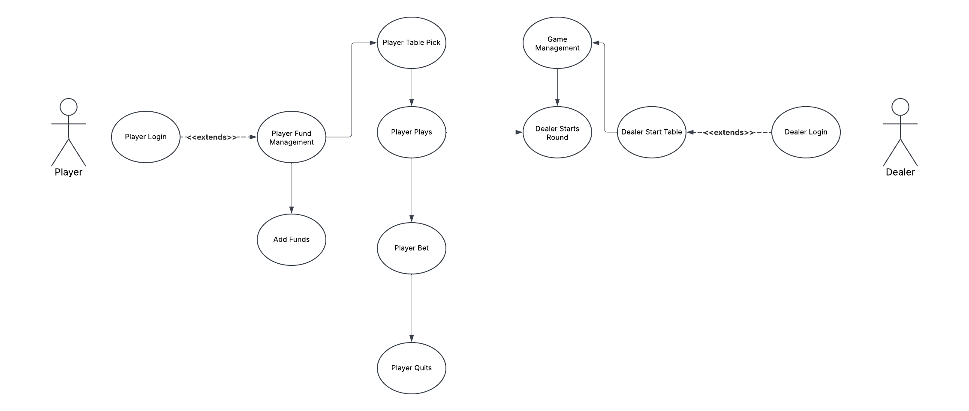

Maybe add more use cases, could separate player and dealer

# 4. **Class Diagrams**

, Picture

Add more classes, revise some of them

# 5. **Sequence Diagrams**

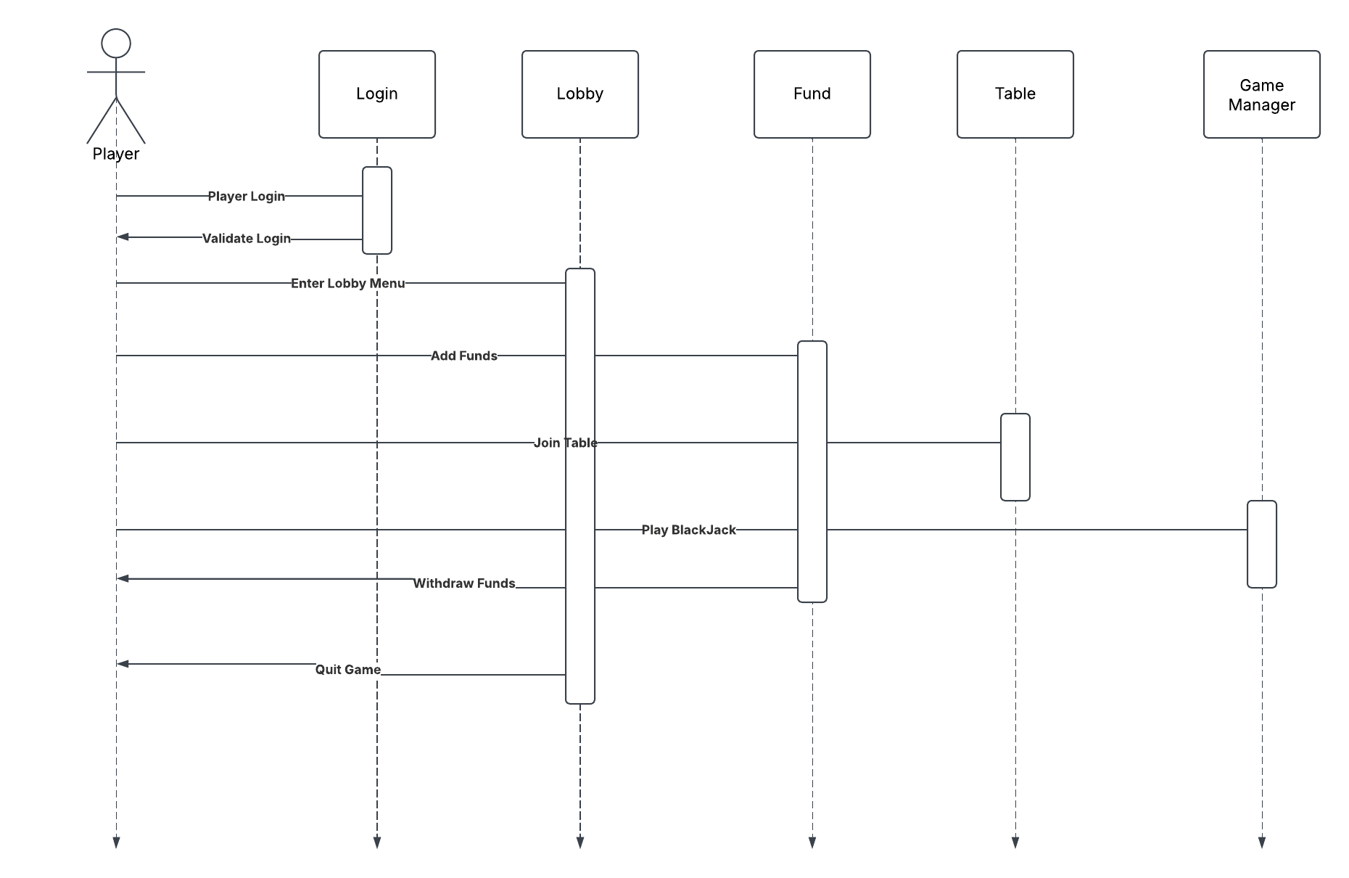

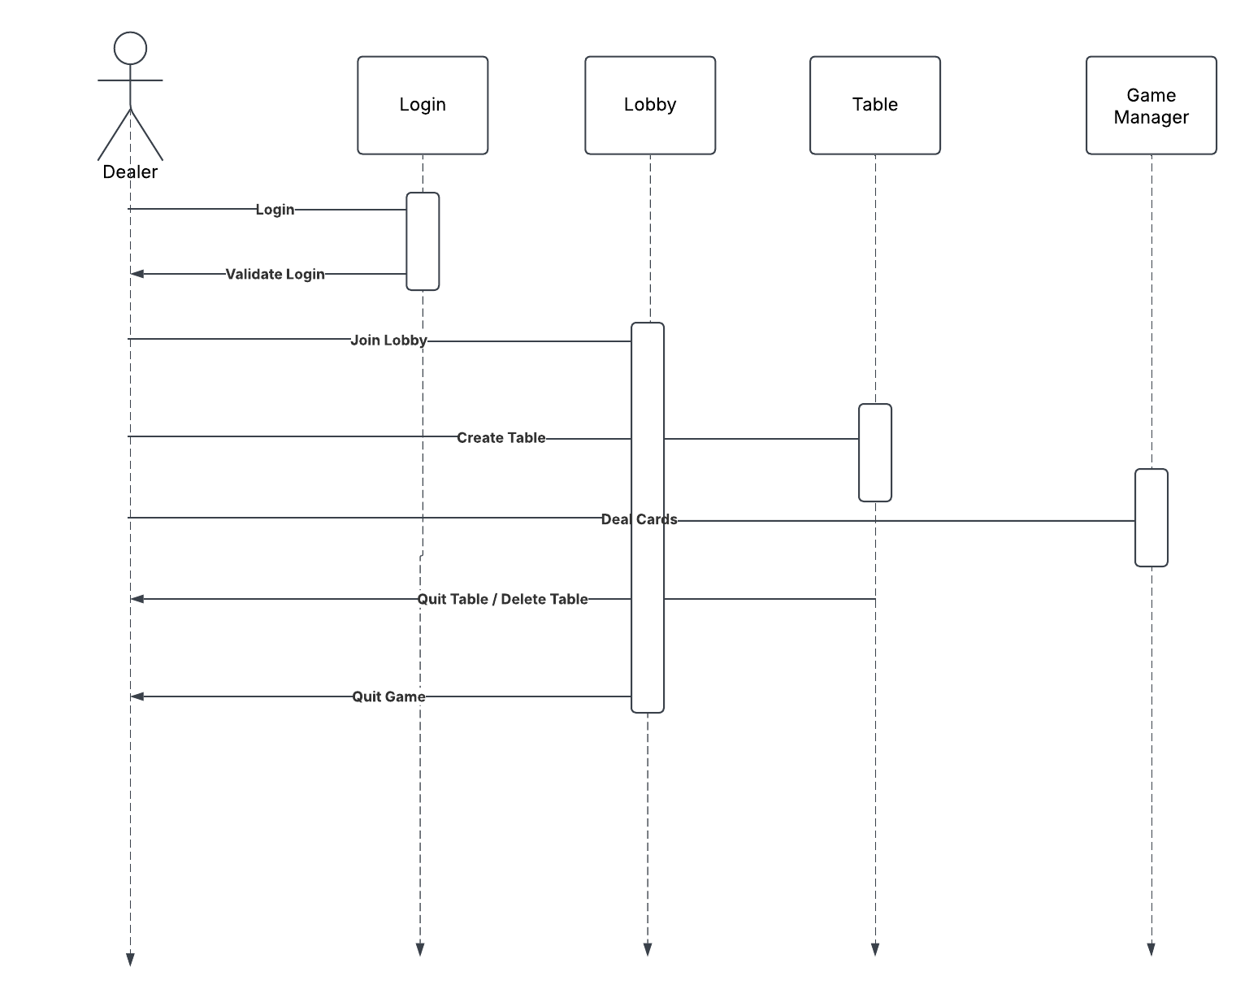

Revamp the whole sequence diagram

# 6. **Interface Design**

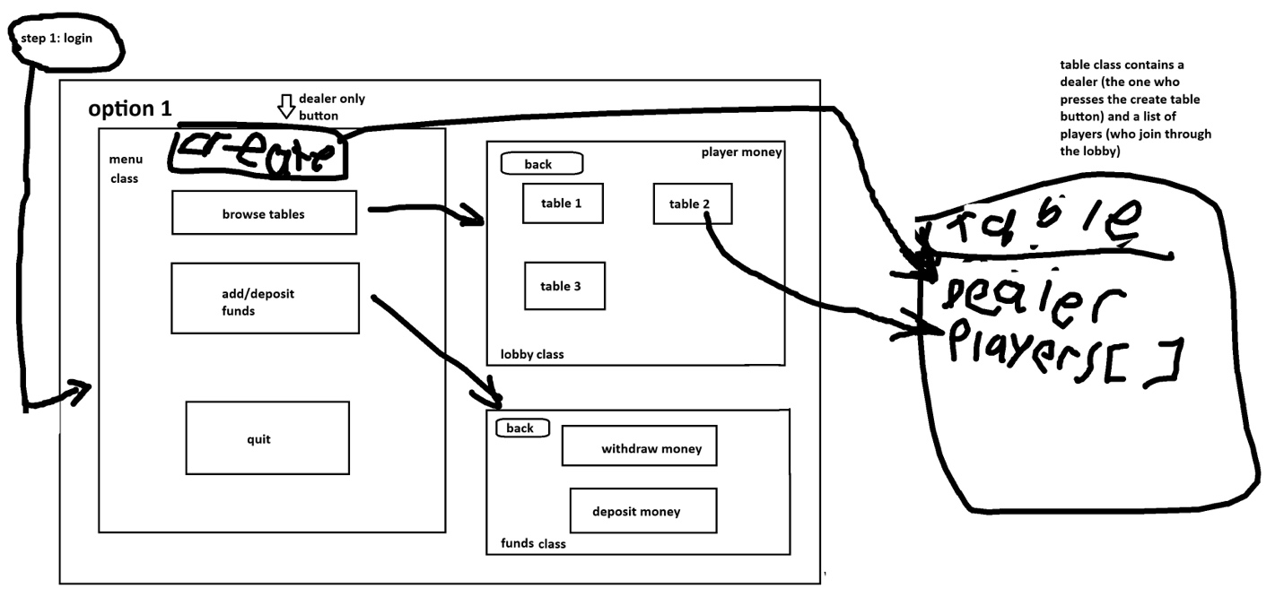

Add more interfaces for client, how depositing withdrawing would look,

